1) Install System Dependencies
Before starting, make sure the required system packages are installed.

1.1 Python and venv support
sudo apt update
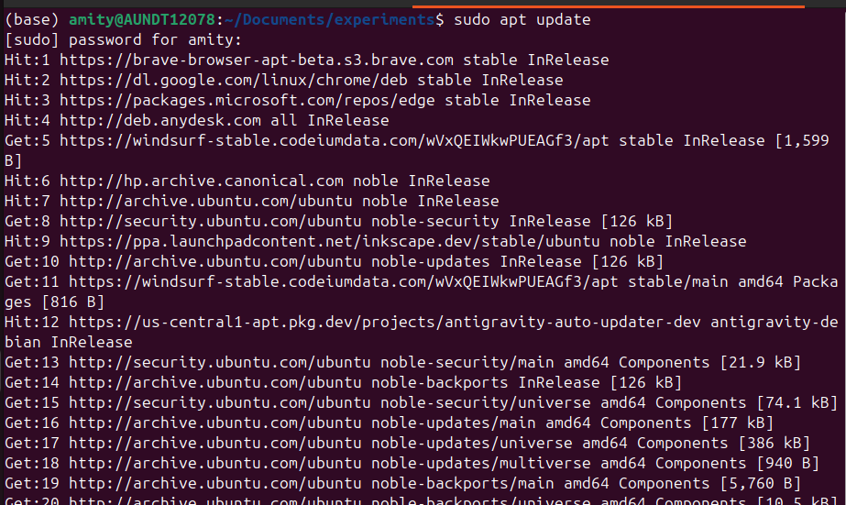
sudo apt install -y python3 python3-venv wget
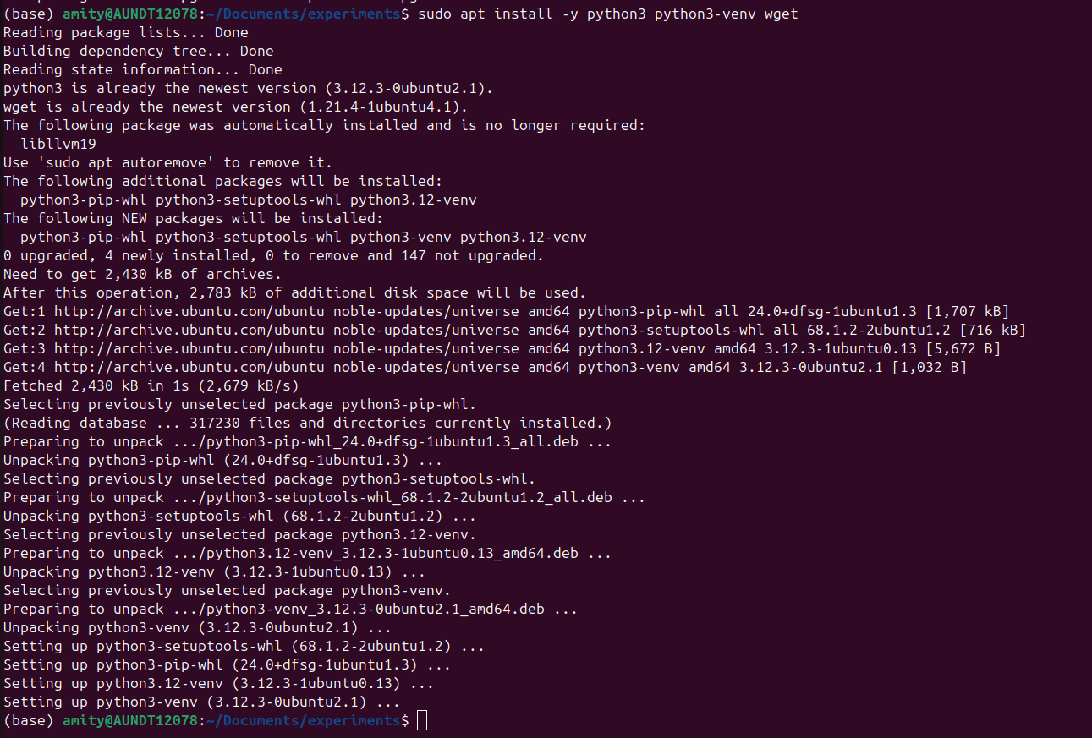

1.2 Install .NET 8
ThermoRawFileParser and MaxQuant require .NET 8.

To find out whether you already have it, type in the command line:

dotnet --version
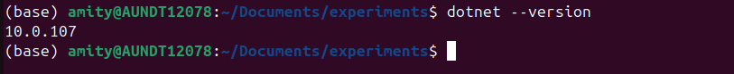

wget https://dot.net/v1/dotnet-install.sh

chmod +x dotnet-install.sh

./dotnet-install.sh --channel 8.0 --install-dir ~/dotnet8
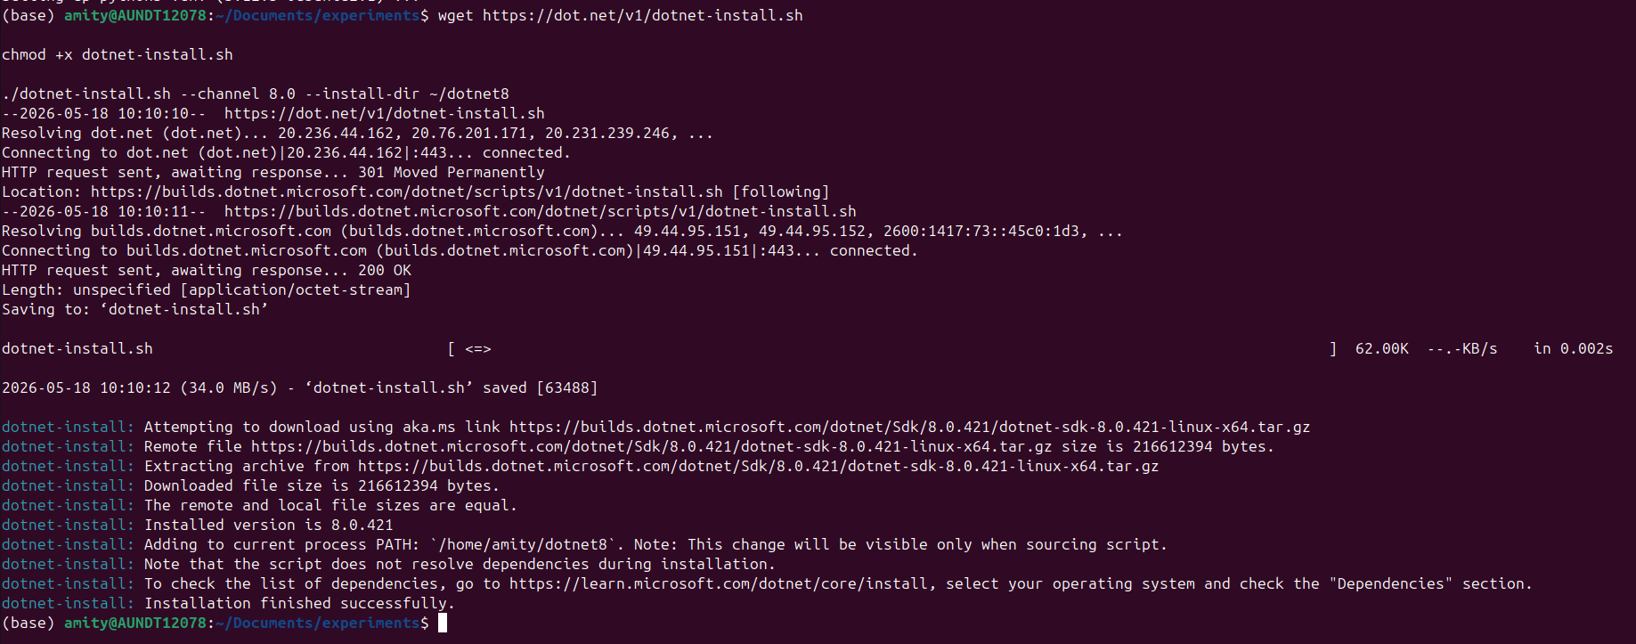

2) Download and Set Up External Tools

2.1 ThermoRawFileParser
Download ThermoRawFileParser from the official GitHub releases page:

https://github.com/compomics/ThermoRawFileParser/releases
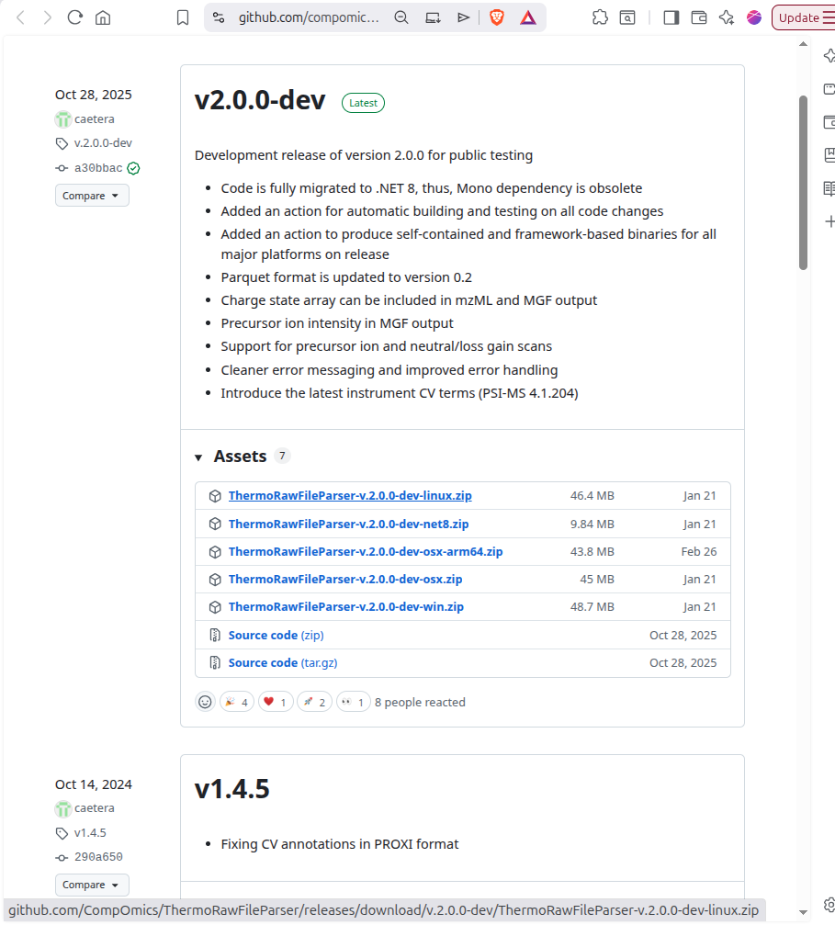

Then extract the files into:

bin/ThermoRawFileParser/
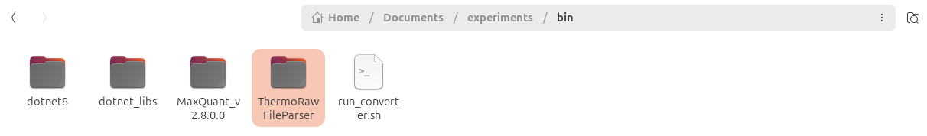

2.2 MaxQuant
MaxQuant_v2.8.0.0.zip
Download and Extract the folder and place it in bin directory of the root folder:

e.g. in [pipelinerootfolder]/bin/MaxQuant_v2.8.0.0/
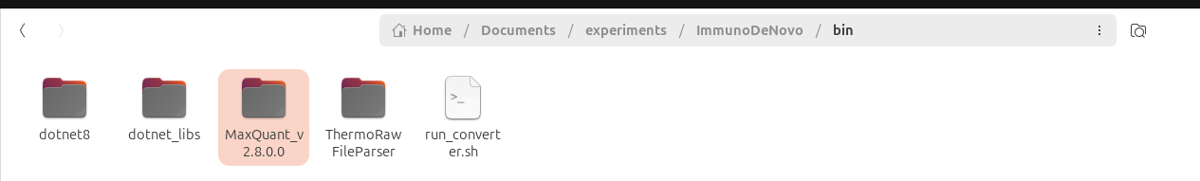

If you are on Windows, you can run it natively. On Linux, use Wine if needed.

3) Create the Python Environment
Create and activate a virtual environment, then install the Python dependencies.

python3 -m venv .venv
source .venv/bin/activate
pip install -r requirements.txt
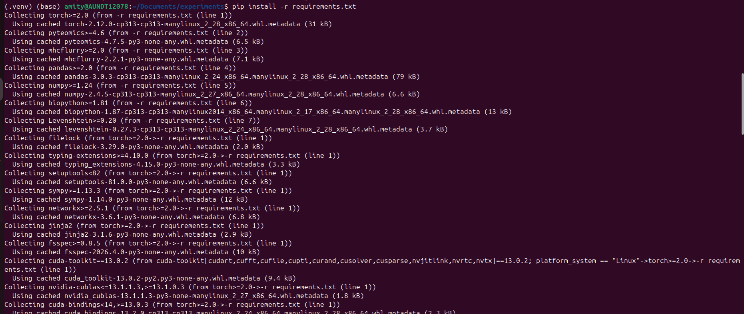
pip install scikit-learn tqdm requests tabulate
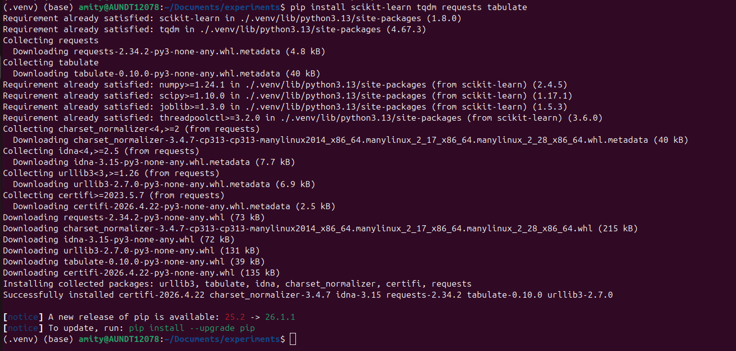
4) Download the Input Data

4.1 Download PRIDE raw files
Run the download script for dataset PXD005231:

python3 src/data_prep/01_download_pride.py -i PXD005231 -o data/raw

This downloads approximately 100 GB of .raw mass spectrometry files from PRIDE.

4.2 Download the reference proteome:

wget -O data/reference/uniprot_human_reviewed.fasta.gz https://ftp.uniprot.org/pub/databases/uniprot/current_release/knowledgebase/complete/uniprot_sprot.fasta.gz
gunzip data/reference/uniprot_human_reviewed.fasta.gz

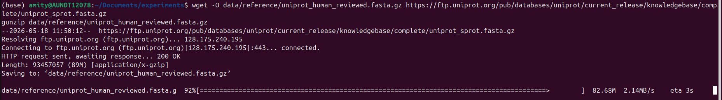

5) Convert RAW Files to MGF
Run ThermoRawFileParser to convert the .raw files into .mgf files.

5.1 Confirm required files
Make sure the following files exist:

bin/dotnet8/dotnet

bin/ThermoRawFileParser/ThermoRawFileParser.dll

5.2 Run the conversion
python3 src/data_prep/02_convert_raw_to_mgf.py

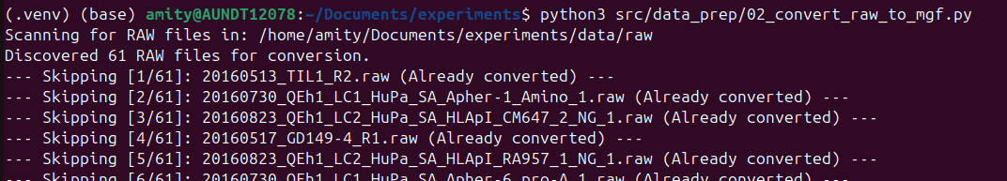

6) Run Database Search with MaxQuant

6.1 Prepare MaxQuant
Ensure MaxQuant is present in the bin directory of the root folder.

6.2 Configure the search parameters
Update:

configs/mqpar_production.xml
ws
Set the FASTA path to:

data/reference/uniprot_human_reviewed.fasta

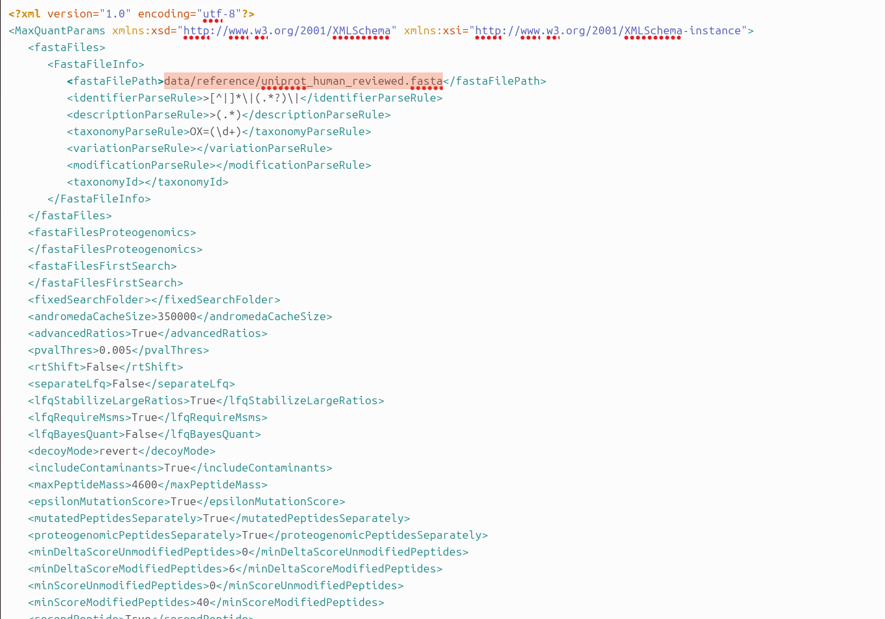

6.3 Run the database search
python3 src/db_search/03_search_database.py
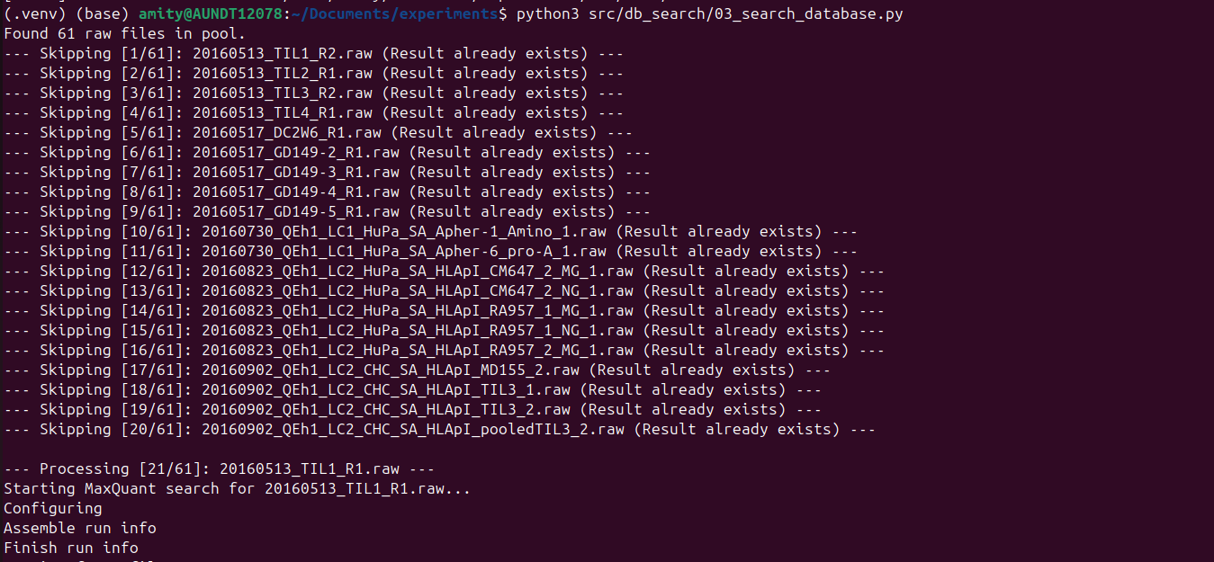
This step typically takes 24–48 hours per batch.

Output files:

data/psms/msms_<rawfile>.txt
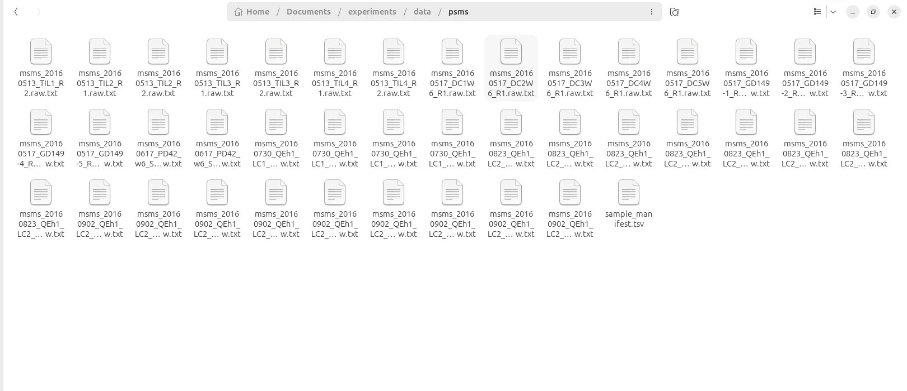

7) Extract PSMs
Extract high-confidence peptide-spectrum matches from the MaxQuant output.

python3 src/data_prep/04_extract_psms.py --input-dir data/psms --output-file results/immunopeptidome_psms.tsv --manifest configs/sample_manifest.tsv
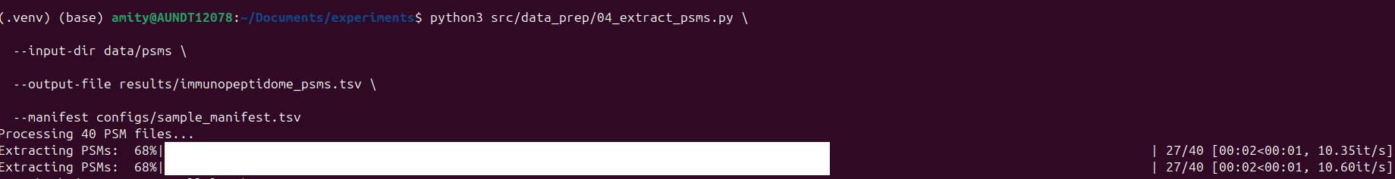

Filtering rules
- Remove decoy hits
- Keep only PEP ≤ 0.01
- Keep only peptide lengths between 8 and 11 amino acids

8) Train the CNN-LSTM Model
Train the de novo model using the prepared MGF files and extracted PSMs.

python3 src/training/05_train_denovo_model.py --mgf-dir data/mgf --checkpoint-dir results/checkpoints --batch-size 32 --epochs 100 --lr 0.001 --num-workers 0
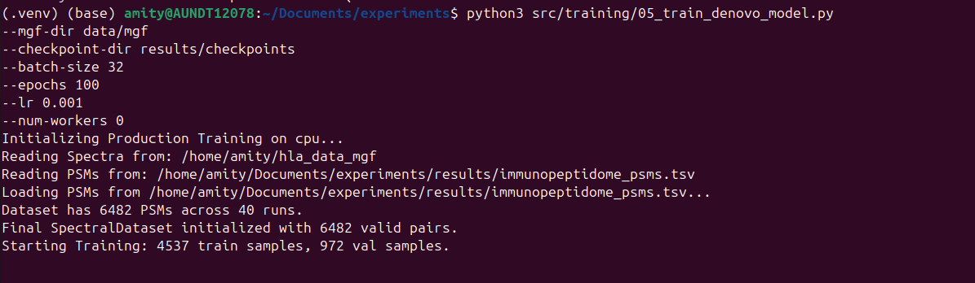

Training setup
- 70/15/15 train/validation/test split
- Stratified by peptide length
- Early stopping with patience = 10

Best model output
results/checkpoints/neoepitope_production_best.pth

9) Run De Novo Prediction
Use the trained model to predict unlabeled spectra.

python3 src/inference/06_predict_denovo.py --mgf_dir data/mgf --psms results/immunopeptidome_psms.tsv --output results/de_novo_candidates.tsv --device cpu --bin_size 0.1
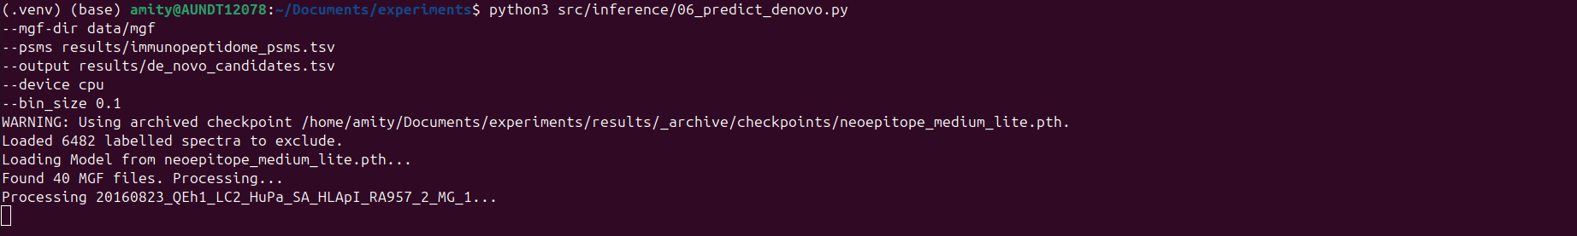

Prediction behavior
- Excludes labeled spectra
- Predicts on unlabeled spectra only
- Applies a 5% FDR filter

10) Filter Neoantigens
Filter the de novo candidates to retain likely neoantigen peptides.

python3 src/postprocess/07_filter_neoantigens.py --input results/de_novo_candidates.tsv --psms results/immunopeptidome_psms.tsv --fasta data/reference/uniprot_human_reviewed.fasta --output results/filtered_neoantigens.tsv --score_cutoff 0.7 --min_psm_support 2
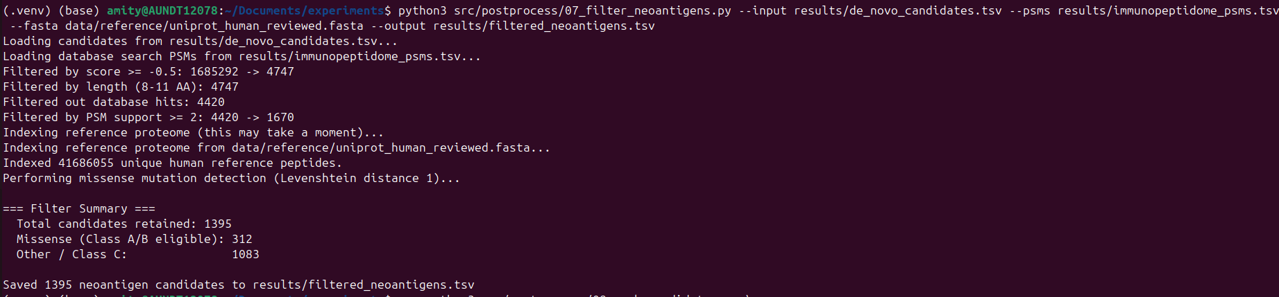

Filtering rules
- Score ≥ 0.7
- Length between 8 and 11 amino acids
- Remove database hits
- Require at least 2 supporting PSMs
- Detect missense mutations using Levenshtein distance 1

11) Rank Candidates
Rank the filtered neoantigens using binding prediction and expression evidence.

python3 src/postprocess/08_rank_candidates.py \

--input results/filtered_neoantigens.tsv \

--manifest configs/sample_manifest.tsv \

--output results/ranked_neoantigens.tsv \

--binding_rank_cutoff 2.0 \

--tpm_cutoff 1.0

Ranking logic
- Uses MHCflurry for HLA binding prediction
- Links RNA-seq TPM values
- Assigns evidence classes A, B, or C

12) Evaluate the Results
Evaluate the ranked predictions against the validated dataset.

python3 src/evaluation/09_evaluate_neoantigens.py \

--input results/ranked_neoantigens.tsv \

--validated data/reference/s2_dataset_extracted/Dataset1/Dataset1.txt \

--manifest configs/sample_manifest.tsv \

--output results/evaluation_report.md \

--top_n 10 25 50

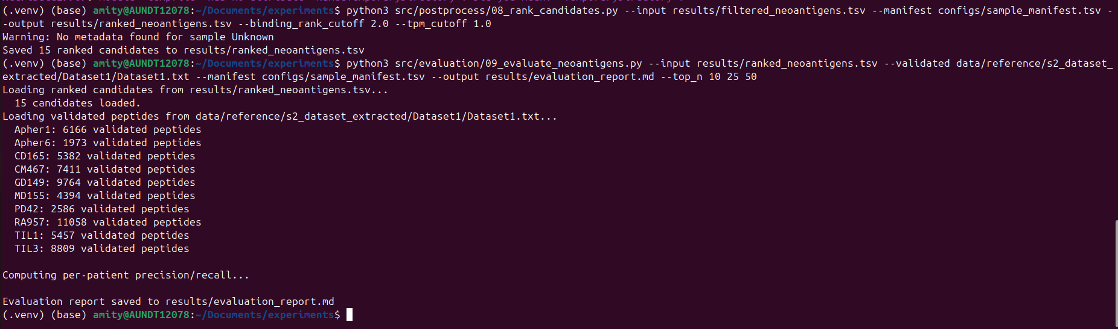

Evaluation output
This step computes:

- Precision
- Recall

The comparison is made against validated neoantigens from Bassani-Sternberg 2016.

13) Run the Full Pipeline
After training is complete, run the full pipeline from de novo prediction through evaluation.

bash run_pipeline.sh

Dry run
bash run_pipeline.sh --dry-run

